**What is docker volume?**

**Whenever you develop or create new container then docker volume get auto generated by docker to manage your container data.**

**You can use below inspect command (check for volume details in output) to confirm exact which data going to be mounted on volume.**

**#docker container inspect “cont id”**

**Below example of volume when you start new container.**

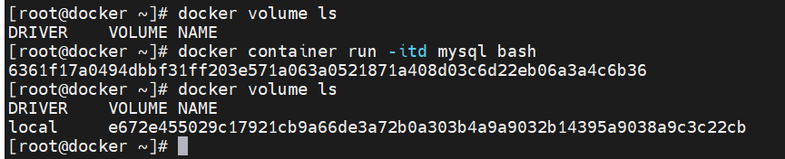

**When you inspect particular container, will get volume details.**

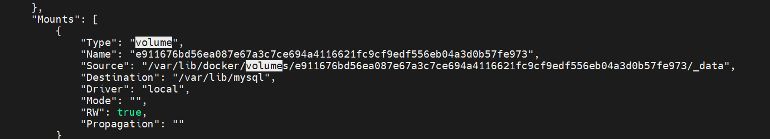

**To run container with specific volume to prevent data loss or it can be use in migration.**



**To create new volumes**

**#docker volume create “vol name”**

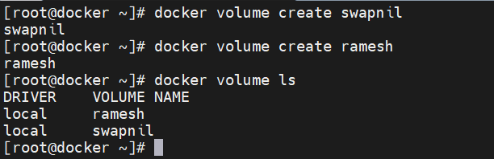

**To remove particular volume**

**#docker volume rm “vol name”**

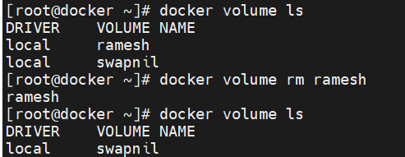

**Below command will remove all unused volume**

**#docker volume prune**

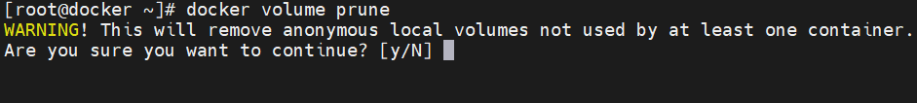

**Note: You can’t delete the volume which are in used by anyway by container (live or unused container). So first you have to remove the container completely to delete the volume assigned.**

**Below command used for bind mount. In below example data present under /root will be mount on /tmp/test/ of container and if you delete mounted data then it will get also removed from source host.**

